Project Design Phase
Solution Architecture
Date | 29 September 2026
Team ID | SWTID-2026-7644
Project Name | Script-Controlled ACL – Restrict Record Access Based on Field Value
Maximum Marks | 4 Marks
Solution Architecture:
Solution architecture describes the major components and data flow that connect the business access-control problem with the proposed technology solution. The architecture defines how a record request is evaluated against a field value before access is granted.
• Provide a clear flow from the user request to the final record-access decision.
• Use a script-controlled ACL to evaluate the configured record field value.
• Combine user role or permission context with the record field value.
• Allow authorized access only when the configured condition is satisfied.
• Record important Allow/Deny decisions for auditing and troubleshooting.
Example - Solution Architecture Diagram:
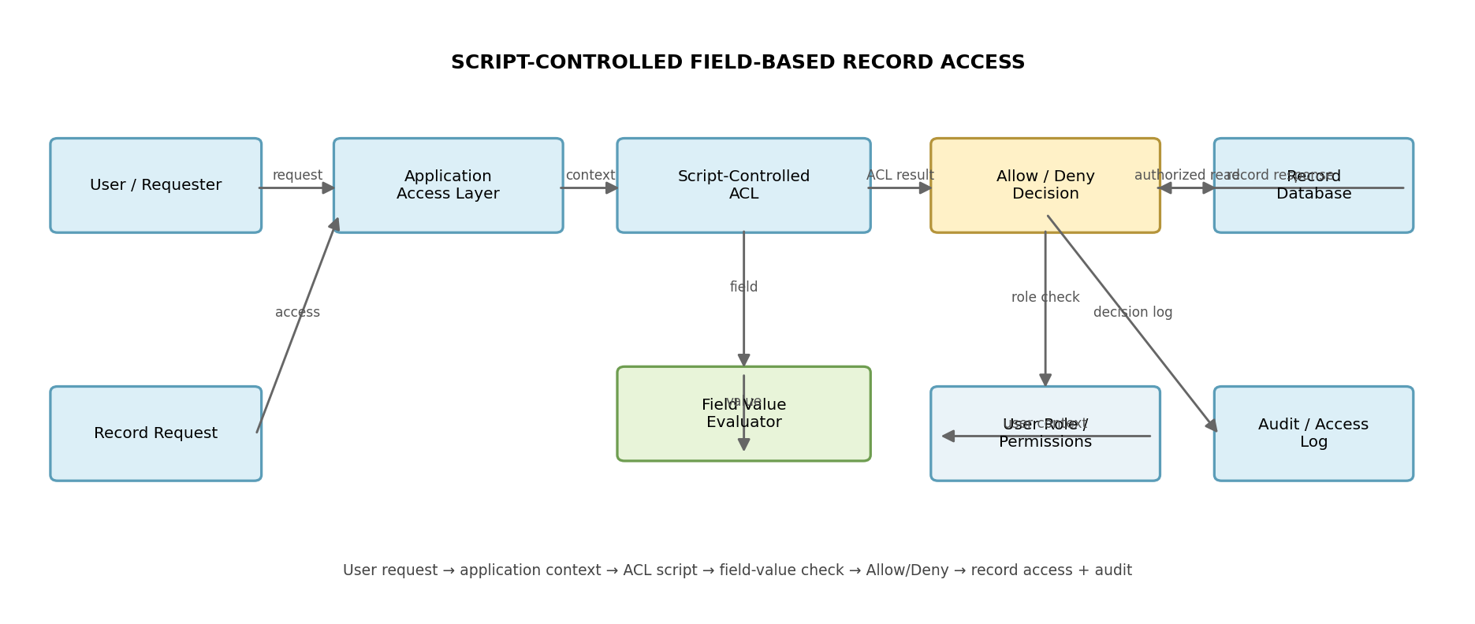
Figure 1: Architecture and data flow of the Script-Controlled ACL solution
Reference:
https://aws.amazon.com/architecture/
https://www.ibm.com/cloud/architecture

